Session to announce USAID support to women entrepreneurs through SAMRIDH Healthcare Blended Finance Facility
Date: 8th March 2022 |Time: 5PM- 6:15 PM IST

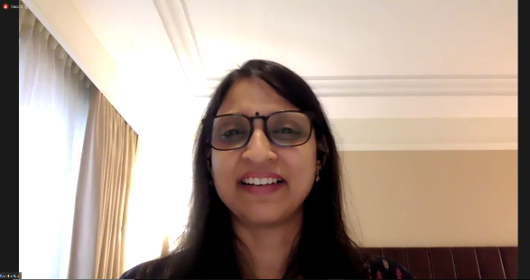
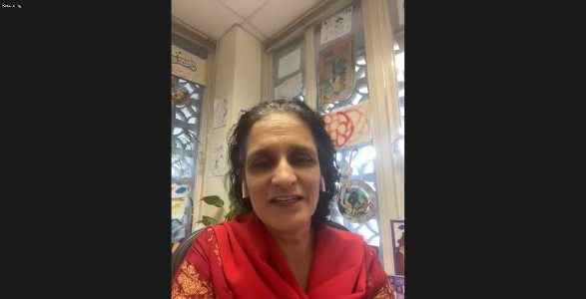
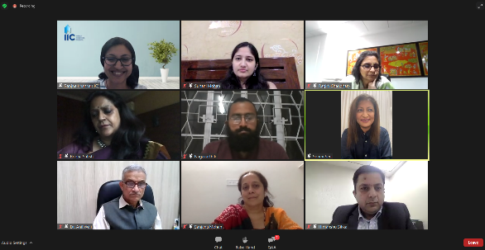
SAMRIDH Healthcare Blended Financing Facility organized a virtual roundtable discussion on the occasion of International Women’s Day, Tuesday, 8th March 2022, from 5pm-6:15pm. This event marked the announcement of a dedicated $5 million USD by USAID to prioritize women-led businesses in healthcare, furthering the recent call for proposals jointly announced by AIM and SAMRIDH. The session also highlighted SAMRIDH’s partnership with Women Entrepreneurship Platform (WEP) and leading financial institutions including U.S. International Development Finance Corporation, Axis Bank, IndusInd Bank, Caspian Debt, and Crypto Relief, to catalyze women entrepreneurship in the healthcare sector,
The session showcased a video to highlight the motivation of all partners to collaborate with SAMRIDH towards the cause of supporting women-led businesses. The event also brought together a diverse panel consisting of women entrepreneurs, representatives of financial institutions, impact investors, and an incubator to discuss the rising need for gender lens investing to solve India's complex healthcare challenges. The panelists offered their perspectives on the socio-economic barriers faced by women entrepreneurs to scale their business and the need for innovative financing models to overcome these challenges.
Over 60 attendees – including representatives from the Ministry of Health and Family Welfare, Government of India, healthcare innovators, impact investors and representatives from development finance institutions – joined the session.

