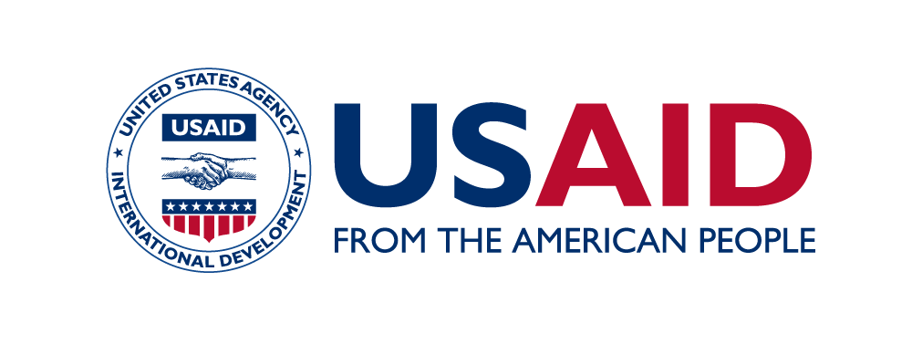
SAMRIDH Learning Session
New Delhi | July 14, 2022

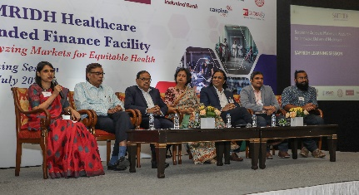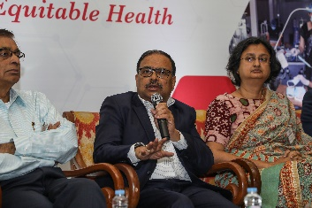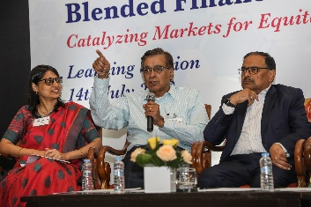
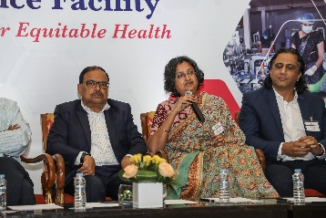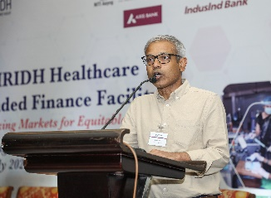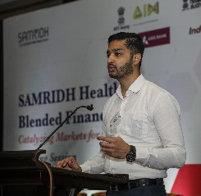

On July 14, SAMRIDH organized a Learning Session on two years of working at the intersection of healthcare and blended finance. The session included an informative, in-depth and lively panel discussion on “Blended Finance – Opportunities & challenges to improve quantity and quality of investment in healthcare”. This was an opportunity to learn from our diverse partners while enabling a platform for knowledge exchange for current and potential stakeholders.
The highlight of the session was a panel discussion on the opportunities and challenges to improve quantity and quality of investment in healthcare using blended finance. Among the panelists were Dr A.K. Nandakumar, Professor of the Practice; Academic Director, Global Programs; Director, Institute for Global Health and Development at Brandeis University, Mr. C.K. Mishra, Former Secretary, Government of India, Ministry of Environment, Forest & Climate Change and Ministry of Health and Family Welfare; Director, IPE Global Limited; and Advisor, Serum Institute, India, Dr. Sapna Poti, Director, Strategic Alliance, Office of Principal Scientific Advisor to the Government of India, Dr. Ashwin Naik, Senior Advisor, Xynteo India, Mr. Sushant Bhatia, Business Head – Start-up and SME Lending and Caspian Debt, and Mr. Nagakarthik MP, Co-founder, Crypto Relief. Dr. Neeta Rao, Senior Health Lead, USAID/India, moderated the panel discussion.
Delivering the keynote address, Dr. Amit Shah spoke about how SAMRIDH enabled social entrepreneurs that was the need of the hour and outlined the various partnerships that SAMRIDH established – from the process of ideas to execution in healthcare innovation. In his presentation, Project Director Himanshu Sikka took the participants on the two-year journey of SAMRIDH since its inception, complete with the challenges it overcame, the opportunities cashed in on, and the partnerships and collaborations it worked for delivering healthcare innovations to ensure equitable access to healthcare for all. More important, Sikka elaborated on the future of innovative financing models in new areas like the Social Stock Exchange that the government was now talking about. We also put a spotlight on five of our investee partners – Blackfrog Technologies, Pluss Advanced Technologies, Redwing Labs, Clensta International, and Skill Tree – who shared their inspiring growth journeys and valuable insights on how SAMRIDH's blended finance approach enabled them to expand their reach to vulnerable communities. Dr. Reuben Swamickan, Acting Health Office Director, USAID/India made the closing remarks, and Dr. Manjunath Shankar, Head, Pre-Award, and Technical team delivered the vote of thanks address.
The panelists focussed on the following key areas to share their perspectives on the opportunities & challenges to improve quantity and quality of investment in healthcare using blended finance.
- The evolving landscape of healthcare in India that makes it a critical sector for innovative financing tools, such as blended finance
- How are development agencies/donor community approaching the use of blended finance – what is working and what needs to change
- The emerging investment trends in healthcare and how blended finance is re-defining the debt financing landscape and capital allocation for healthcare
- The motivation for philanthropic organisations to partner in blended finance solutions to mobilize investments in healthcare

