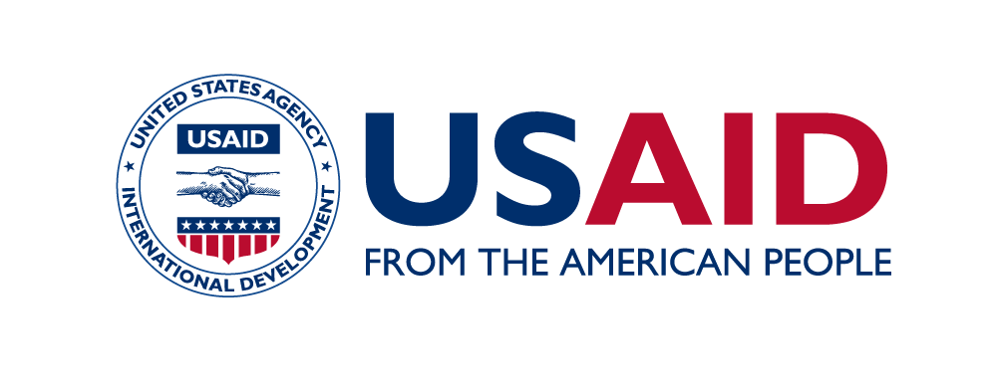
Indian Blended Finance Collaborative | Masterclass Series
Masterclass #1: How Philanthropic and CSR Capital can Leverage the Power of
Blended Finance to Deliver Greater Social Impact
Virtual | September 1, 2022

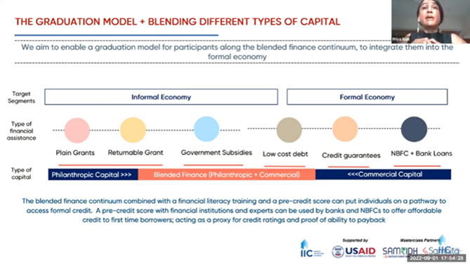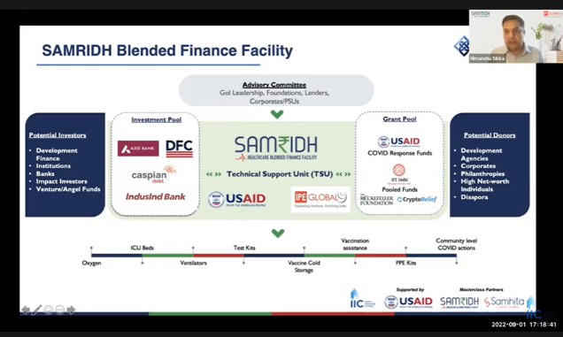

SAMRIDH Healthcare Blended Financing Facility, supported by USAID, participated in a panel discussion On the 1st of September 2022 hosted by Impact Investors council (IIC) in association with USAID, which launched the first edition of their newest masterclass series on Blended Finance supported in partnership with SAMRIDH healthcare and Samhita Social Ventures. The session was attended by Corporate CSR units, NGO’s, MSME owners, Impact fund accelerators, development agencies, and students interested in the field of blended finance.
The masterclass was conducted with the support of SAMRIDH, a blended finance facility that is working towards creating a seamless blended finance ecosystem, and Samhita Social Ventures, a blended finance facility as well as a livelihood accelerator to help informal workers and micro-entrepreneurs recover from the COVID-19 pandemic. The session was divided into three halves focussing on establishing a base for the future sessions for the viewers regarding what blended finance is and how it fits in the current economic systems.
Mr. Himanshu Sikka, Project Director, SAMRIDH Healthcare Blended finance Facility and Chief Strategy & Diversification officer, IPE Global focussed his session on establishing the how’s and why’s of Blended Finance that makes it such a powerful tool for social impact. He emphasised on the various types and structures of blended finance instruments that he showcased through practical real-world examples of organisations funded through SAMRIDH. Questions such as what the important prerequisites for a transaction are, how more entrepreneurs can join the ecosystem, how is blended finance transforming the market were elucidated by Mr Himanshu Sikka during the session as well. Taking on from Mr Himanshu, Ms. Priya Naik (Samhita), Mr. Abinav (Dell Foundation) and Ms. Soumya (IIFL Management) focussed their session on showcasing the place of philanthropic and CSR capital in participating in blended finance under current regulatory frameworks. Leading initiatives such as the REVIVE Alliance, a USD $20million blended finance facility and livelihood accelerator is helping informal workers and micro-entrepreneurs to recover from the COVID-19 pandemic and thrive. This session’s focus was to show how collaboration at scale can be driven through multi-stakeholder participation. The final session was conducted by Mr. Apoorv Shukla, Lead - Innovative Development Finance, USAID India. Being one of the leaders in this space and having funded both Samhita and SAMRIDH, Mr Shukla recounted the diverse and dynamic experiences that USAID has had in this space in India.
This series is part of an ongoing partnership with U.S. Agency for International Development (USAID) and the Impact Investors Council (IIC), a multi-stakeholder initiative, the India Blended Finance Collaborative (IBFC). IBFC is working with a diverse base of commercial, philanthropic, and public stakeholders to discuss, improve and increase the use of blended finance approaches to achieve Sustainable Development Goals by 2030.

