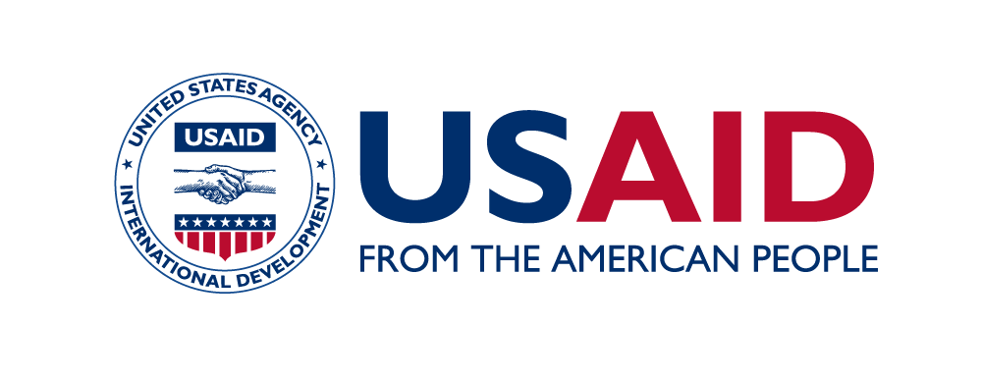
Prabhav 2022
New Delhi | September 12-13th, 2022

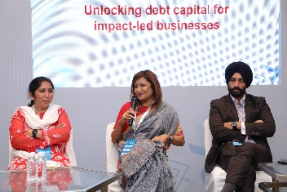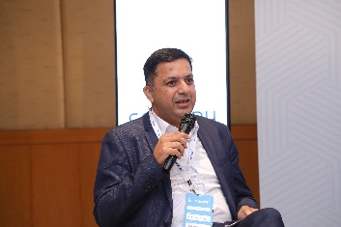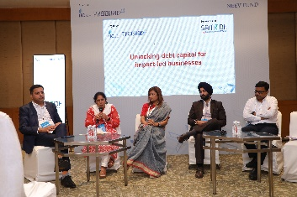
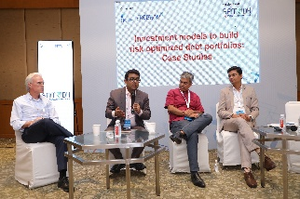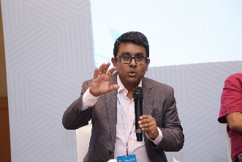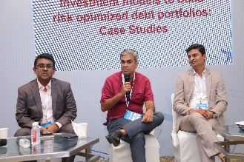

On 12th and 13th September, SAMRIDH participated in Prabhav 2022, the flagship initiative by the Indian Investors Council (IIC). Prabhav aims to brings together the key players Global Impact Investing Industry through a series of insightful sessions, workshops and conversations. It aims to build a platform for conversations around blended finance and impact investing in India. SAMRIDH had the pleasure of leading two sessions in this conference namely; “Investment Models in Indian Debt Impact Investing” led by Himanshu Sikka, Project Director, SAMRIDH and “Building Risk-optimized Debt Impact Portfolios Masterclass”, which featured Archish Gupta CFA, Associate Director, IPE Global & Lead – Blended Finance, SAMRIDH. The sessions’ focus was on understanding and mediating the debt impact landscape in India, its growth, scalability and sustainability in the Indian context with special emphasis on expanding these various models across various sectors.
The First Session led by Himanshu Sikka focussed on showcasing and discussing real time blended and impact investment models from varying sectors and perspectives, the panelists featured include: Sohini Sen, Head – Financial Inclusion and Priority Sector Lending, Axis Bank; Abhijit Ray, Co-Founder And Managing Director, Unitus Capital; Bama Balakrishnan CFA, Executive Director & Chief Operating Officer, Northern Arc Capital; Ishpreet Gandhi, Founder, Stride Ventures & Stride One. The discussion saw an interesting mix of players from the blended finance landscape coming together to discuss its present and future in India through case studies and real time example of how these models would look like when implemented.
The panel focussed on demystifying and understanding the blended finance landscape of India. Speaking of debt financing and its role in blended finance, the experts spoke about how the multiplier effect comes into play creating reasonable profitability for investors. The thought of extending these structures to other sectors such as farming, education and climate action was looked at and discussed as a viable option for these sectors. It was however pointed out that before thinking about implementation, creating access is more important to ensure sustainable growth and scalability of blended financing models in India. The session saw panellists sharing their own and their company’s experiences with impact investment through a series of case studies. The session concluded on the note that building optimised debt impact models are the future of impact investing, while the ball is rolling there is a long way to go.
While the second session was moderated by Bryan Byrne, Supervisory Private Enterprise Officer, Development Partnerships And Innovations Office, USAID/India with the attendance of Avishek Gupta, Managing Director And Chief Executive Officer, Caspian Debt; Royston Braganza, Chief Executive Officer, Grameen Impact Investments India along with Archish Gupta. This session aimed at demystifying the building of a risk optimised debt impact portfolio in today’s landscape. The discussion shined a spotlight on measures that regulators can take and various paths available for investment; the importance of synergies between funding vehicles such as blended finance and debt capital along with philanthropic stakeholders; and striking a balance to achieve sustainable growth of debt investment.
Few highlights of the discussion were:
- Debt capital plus philanthropic funding can have a very good multiplier effect when used effectively
- Institutional and portfolio level guarantees have made difficult to access development pool of capital
- It is imperative for the various stakeholders in this landscape to find a synergy before securing capital
- Access is the biggest problem currently in the healthcare landscape
- It is important for players to adjust themselves to their markets for maximum payout

